Last Updated: 3/13/15

**Topic Name:** Application Controller Pattern

**Brief Introduction:**

The purpose of this design pattern is to help simplify how an application processes things such as views to a user or to help break down the application into more modular pieces that can be used to test the code. Think of it as being a view-management handler or a request-handler.

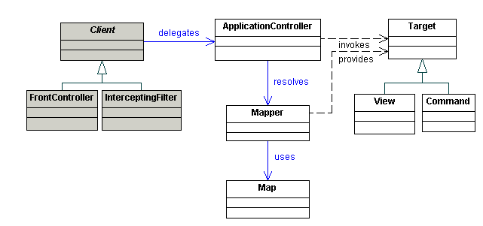

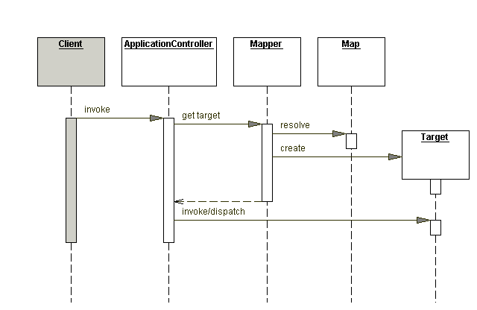

(Pictures from:[**http://www.corej2eepatterns.com/ApplicationController.htm**](http://www.corej2eepatterns.com/ApplicationController.htm)**)**

**Teaching Description:**

None yet.

**Teaching Examples:**

None yet.

**Files to View:**

None yet.